**Input Test case1:**

Adjustment of Interest Rate for Loan #56789.eml



**Output Test case1:**



**Input Test case2:**

Inquiry on Interest Rate for Loan Servicing.eml



**Output Test case2:**



**Input Test case3:**

LOAN PRINCIPAL ADJUSTMENT - SIGMA ENTERPRISES.eml



**Output Test case3:**



**Input Test case4:**

Loan Repayment and Interest Rate Adjustment Notification.eml



**Output Test case4:**



**Input Test case5:**

please find interest rates in attachment.eml



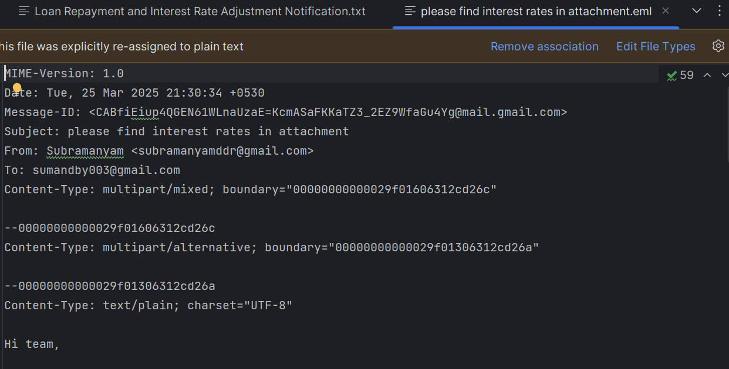

**Output Test case5:**



**Input Test case6:**

Request for Interest Rate Modification – Loan #456789.eml

**Output Test case6:**

